Supporting Information
“Global Afforestation Carbon Sequestration Potential (AFRCSP) within an Integrated Environmental and Sustainable Food System Framework”

S1. Supplementary Information related to model used
S2. AFRCSP Methodology
S3. Supplementary Information related to Scenario designed
S4. Supplementary Information on Result Analysis and Validation
S5. Supplementary Information related to scope and limitations

S1. Supplementary Information related to model used
S1.1 AIM-Hub model
Regional land-use demand projections were generated using the Asia-Pacific Integrated Model–Computable General Equilibrium (AIM-Hub; formerly AIM-CGE) (Fujimori et al., 2012). AIM-Hub is a recursive dynamic computable general equilibrium model that has been widely applied to assess climate mitigation, land-use change, agriculture, and food-system transitions (Hasegawa et al., 2014, Hasegawa et al., 2015a Hasegawa et al., 2015b, Hasegawa et al., 2016).
The model describes supply, demand, trade, and investment through behavioural functions that respond to commodity prices, production factors, technological change, population growth, gross domestic product (GDP), and consumer preferences. AIM-Hub contains 42 industrial sectors, including 10 agricultural sectors, and represents the global economy through 17 aggregated regions (Table S1).
Production activities are represented using nested constant elasticity of substitution (CES) functions. Land is included as a production factor for agricultural and forestry sectors. Allocation of land among competing sectors is determined using a multinomial logit formulation based on land rent, allowing different substitution elasticities among land categories.

S1.2 AIM-PLUM model
The Asia-Pacific Integrated Model–Platform for Land Use and Environmental Model (AIM-PLUM) is a spatially explicit land-use allocation model operating at a spatial resolution of 0.5° × 0.5°.
Regional land-use demands generated by AIM-Hub were downscaled to grid cells through AIM-PLUM. The model allocates land according to biophysical productivity, land conversion costs, irrigation conditions, and land suitability while maintaining consistency with regional land-use demands.
Cropland allocation is based on profit maximization under constraints imposed by land productivity, irrigation availability, and conversion costs. Due to limited information regarding future livestock profitability, pasture distribution is adjusted around the baseline distribution to satisfy future pasture demand while minimizing land development costs.
Forest and other natural vegetation are allocated according to carbon stock density. A threshold carbon stock density is used to distinguish forest from grassland and ensure consistency with observed forest statistics. Land-use allocation is conducted in 10-year time steps. Additional details regarding AIM-PLUM are provided in Hasegawa et al. (2017).

Table S1. Region’s category in AIM model
This table describes the regions in Asian-Pacific Integrated Model (AIM) and classification based on regions.
AIM Code | Explanation | Region Group
JPN | Japan | OECD and EU
CHN | China | ASIA
IND | India | ASIA
XSE | Southeast Asia | ASIA
XSA | Rest of Asia | ASIA
XOC | Oceania | OECD
XE25 | EU25 | OECD
XER | Rest of Europe | Reforming Economy
CIS | Former Soviet Union | Reforming Economy
TUR | Turkey | OECD
CAN | Canada | OECD
USA | United States | OECD
BRA | Brazil | Latin America
XLM | Rest of South America | Latin America
XME | Middle East | Middle east and Africa
XNF | North Africa | Middle east and Africa
XAF | Rest of Africa | Middle east and Africa

S2. AFRCSP Methodology

S2.1 Identification of Available Land for Afforestation
Potential afforestation land was derived from AIM-PLUM land-use projections after satisfying future demands for cropland, pasture, bioenergy production, urban expansion, and other competing land uses. In contrast to the default AIM-PLUM framework, where afforestation emerges endogenously through land-use competition, this study first identified potentially available land and subsequently applied environmental and biophysical filters to determine suitable afforestation areas (Figure S1). This approach was adopted to estimate the technical potential of afforestation under sustainable land-use conditions.
Figure S1. Comparison of afforestation land allocation in the default AIM framework and this study.
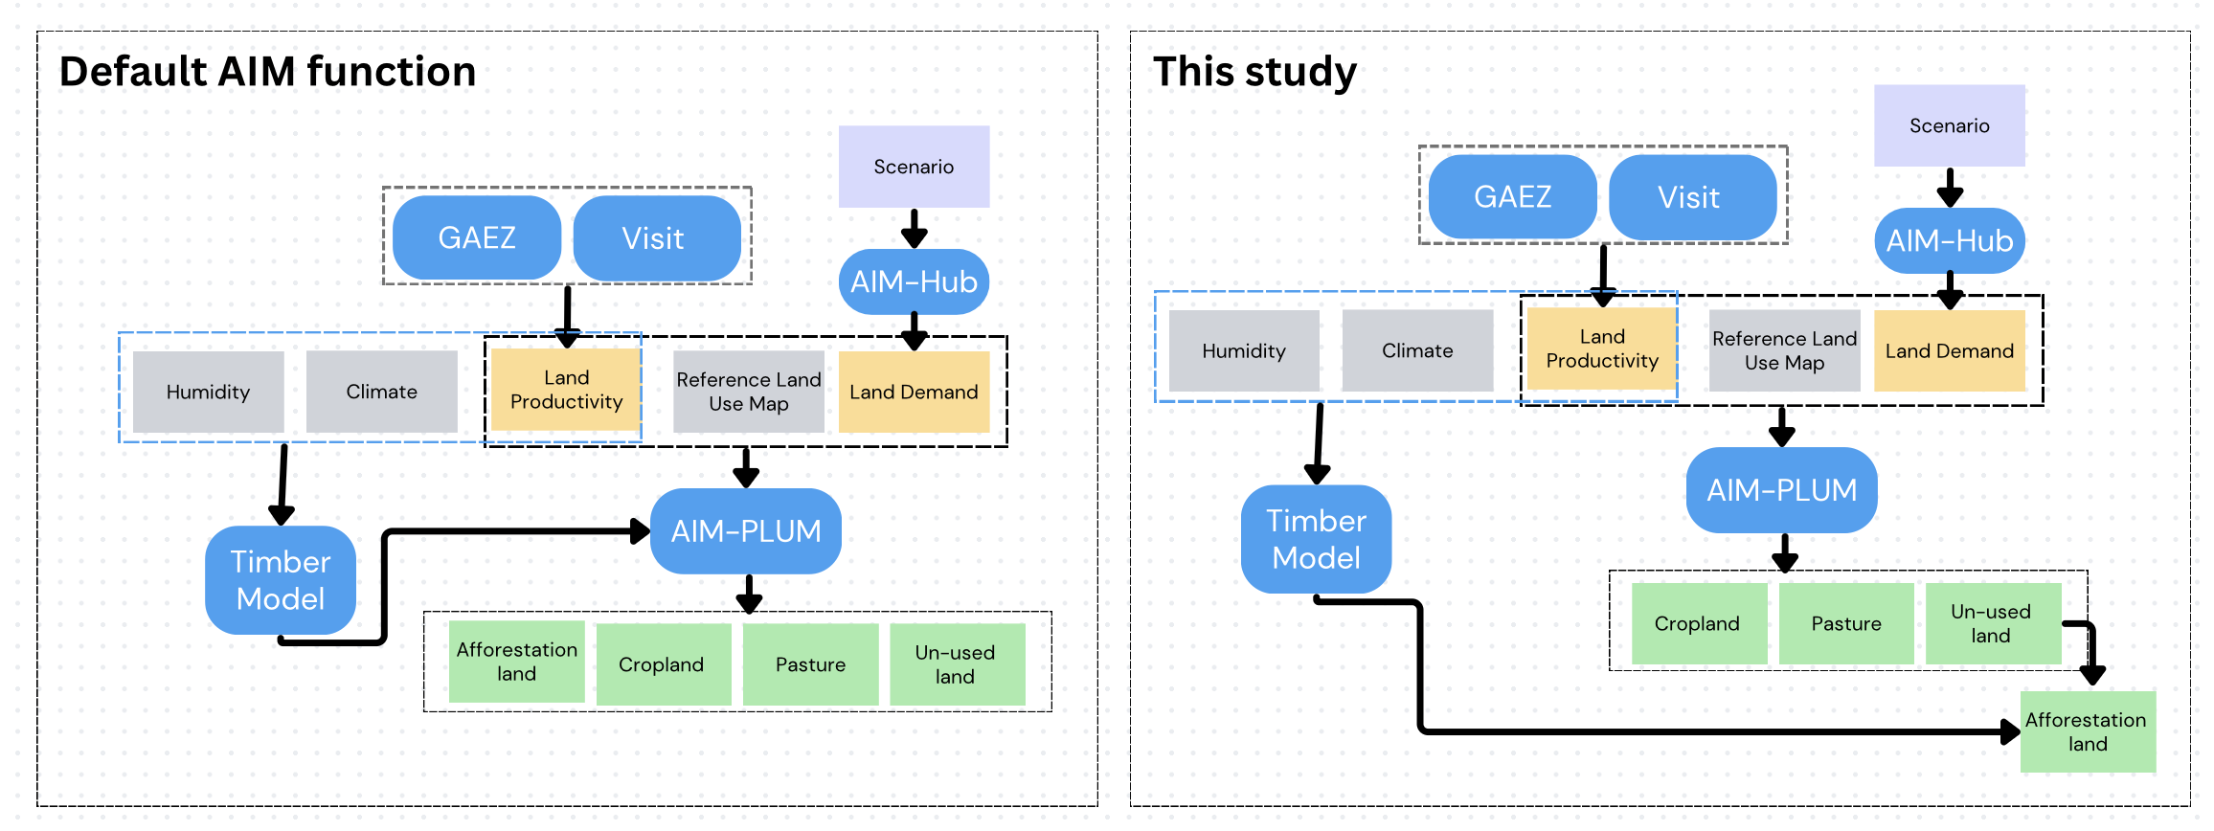

Table S2. Key differences between the default AIM implementation and the methodology adopted in this study.
Parameter | Default AIM function | This study
Afforestation rate (Forest land expansion) | Not considered | Gradual forest expansion explicitly represented
Carbon intake rate | Based on a fixed forest age (20 years) | Based on full forest growth over the lifetime (Sohngen et al., 2009)
Afforestation land | Determined by policy-driven demand | Restricted to available unused land
Afforestation cost | Considered in policy driven demand | Calculate explicitly after carbon sequestration calculated

S2.2 Forest Growth Parameters
Potential biomass carbon stock densities were assigned according to IPCC agroecological zones based on climate and humidity classes (Table S3). These values were used together with the timber yield function to estimate biomass accumulation and carbon sequestration.
Table S3. Forest type and biomass carbon stock density by agroecological zone.
Climate | Humidity | Forest type/  Ecological Zone | Potential carbon stock Density (tonnes d.m. ha-1) (IPCC, 2016 Table 4.12)
Tropical | Arid | Tropical shrubland | 30
Tropical | Dry arid | Tropical dry forest | 60
Tropical | Moist arid | Tropical dry forest | 60
Tropical | Subhumid | Tropical moist deciduous forest | 120
Tropical | Humid | Tropical rain forest | 150
Tropical | Humid dry | Tropical rain forest | 150
Temperate | Arid | Temperate Continental | 100
Temperate | Dry arid | Temperate  Continental | 100
Temperate | Moist arid | Temperate Continental | 100
Temperate | Subhumid | Temperate Oceanic Forest | 160
Temperate | Humid | Temperate Oceanic Forest | 160
Temperate | Humid dry | Temperate Oceanic Forest | 160
Boreal | Arid | Boreal Tundra Woodland | 15
Boreal | Dry arid | Boreal mountain systems | 30
Boreal | Moist arid | Boreal mountain systems | 30
Boreal | Subhumid | Boreal coniferous forest | 40
Boreal | Humid | Boreal coniferous forest | 40
Boreal | Humid dry | Boreal coniferous forest | 40

S2.3 Land-Use Stability Constraint
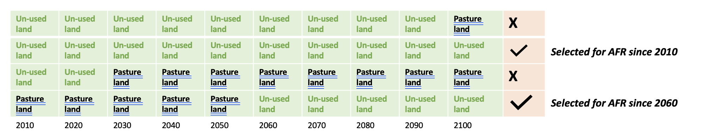
Figure S2. Illustration of the land-use stability constraint.

S2.4 Afforestation Rate Assumption
Afforestation expansion was constrained using an annual afforestation rate derived from the Global Forest Goal, which targets a 3% increase in global forest area. This corresponds to approximately 23 Mha yr⁻¹ globally and is equivalent to afforesting about 1.1% of available land annually under the most ambitious scenario. The parameter was used to represent implementation constraints related to financing, labour, governance, and forest establishment capacity.

S2.6 Afforestation Cost Estimation and Supply Curve Construction
Afforestation costs were estimated following Doelman et al. (2020) and included land-transition and monitoring costs. Land-transition costs comprised site preparation, planting, maintenance, weed control, and replanting activities. Cost parameters were derived from Winsten et al. (2011). Opportunity costs were excluded because afforestation was restricted to land not allocated to competing productive uses.
Carbon supply curves were constructed following Hoogwijk et al. (2009), van Vuuren et al. (2009). AFRCSP and associated costs were first calculated for each 0.5° grid cell. Grid cells were then ranked by mitigation cost, and cumulative sequestration potential was calculated across progressively increasing carbon-price thresholds to generate regional and global supply curves.
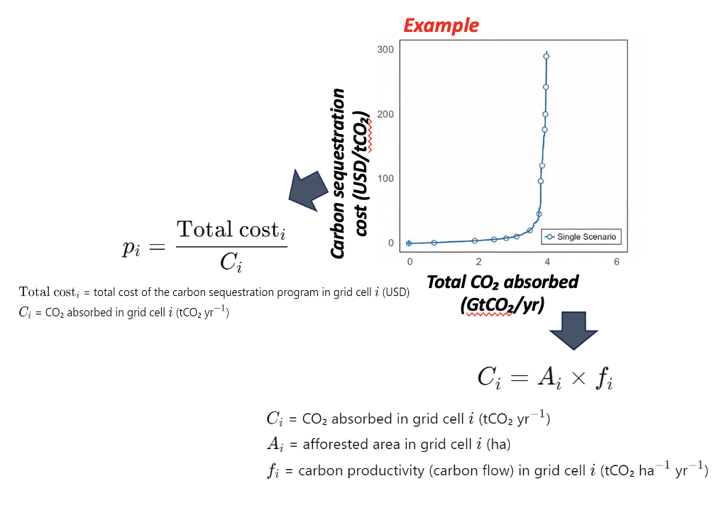
Figure S3. Example of afforestation carbon supply curve construction.

S3. Supplementary Information related to scenario designed

S3.1 Biodiversity Protection
Protected areas were identified using two major global conservation datasets: the World Database on Protected Areas (WDPA) (IUCN & UNEP-WCMC, 2018) and the World Database of Key Biodiversity Areas (KBA) (BirdLife International, 2017). As of 2018, the WDPA covered approximately 33.6 million km² globally, while KBA sites covered approximately 19.9 million km².
To further identify ecologically important regions, we utilized a spatially explicit biodiversity index developed within the AIM/Biodiversity framework. This index was constructed using climate variables and land-use information from 2005 to estimate potential habitat suitability for 9,025 species worldwide using the Maximum Entropy (MaxEnt) modeling approach (Phillips et al., 2006). Species distributions were subsequently aggregated into a biodiversity index representing the relative ecological importance of each grid cell (Ohashi et al., 2017).
Under the BAU scenario, only existing forest protected areas from WDPA were excluded from land-use allocation. Under the biodiversity protection scenario, additional biodiversity-sensitive regions, including Key Biodiversity Areas and high-biodiversity grid cells identified by AIM/Biodiversity, were designated as protected zones and excluded from afforestation and other competing land-use activities.
Although afforestation can provide biodiversity benefits in some contexts, large-scale tree planting may also create ecological conflicts when implemented in naturally non-forest ecosystems or species-rich habitats. Therefore, biodiversity-sensitive areas were excluded from afforestation expansion to avoid potential habitat loss and ecological degradation. This approach is supported by evidence showing that many KBAs contain unique ecosystems and species assemblages requiring conservation priority. Approximately 54% of KBA areas are currently forested, while the remaining areas consist of diverse ecosystems including grasslands, wetlands, mountains, reefs, and coastal habitats (Crowe et al., 2023).

S3.2 Soil Quality Enhancement
The soil quality enhancement scenario focused on restoring degraded land through afforestation. Degraded lands were identified using the Global Land Degradation Information System (GLADIS) dataset. Areas classified as severe and serious degradation were prioritized for afforestation and excluded from alternative land-use expansion.
Afforestation on degraded land is widely recognized as an effective strategy for ecological restoration and climate change mitigation. Compared with agricultural land or grasslands, degraded lands often possess low initial soil organic carbon (SOC) stocks, providing substantial opportunities for carbon accumulation following forest establishment.
Although soil physical, chemical, and biological properties were not explicitly simulated within the integrated assessment framework, extensive literature demonstrates that afforestation can improve soil quality through increased organic matter inputs, enhanced nutrient cycling, improved soil structure, and reduced erosion (Lefebvre et al., 2021). Based on this evidence, afforestation on degraded land was assumed to contribute to soil quality enhancement and ecosystem restoration.
The environmental consideration scenarios in this study were designed primarily from a land-use allocation perspective. Biodiversity protection was represented through spatial exclusion of ecologically sensitive areas, while soil quality enhancement was represented through prioritization of degraded land for afforestation. Other environmental dimensions, including water scarcity, nutrient runoff, and soil salinization, were not explicitly incorporated within the modeling framework.

S3.3 Dietary Shift and Food Waste Reduction
The dietary shift scenario assumed a transition toward healthier and more sustainable consumption patterns consistent with the recommendations of the EAT-Lancet Commission (Willett et al., 2019). Specifically, consumption of red meat and dairy products was reduced and replaced by greater consumption of plant-based protein sources such as legumes, beans, lentils, and pulses.
Daily food consumption was constrained to 2,503 kcal per capita, reflecting recommended levels for balanced nutrition and sustainable food systems. In addition, food loss and waste were reduced following Sustainable Development Goal (SDG) 12.3, which aims to halve global per-capita food waste (Ardra and Barua, 2022).
These assumptions were maintained throughout the simulation period to 2100. Reduced food demand and lower waste generation decreased the amount of agricultural land required to satisfy global food consumption. Consequently, additional land became available for afforestation, ecosystem restoration, and carbon sequestration.

S3.4 Trade and Irrigation Intensification
Trade openness was represented through modifications to international trade elasticities within the AIM-Hub framework. The BAU and environmental consideration scenarios retained default SSP2 trade assumptions, representing moderate globalization and trade integration.
The trade intensification scenario adopted SSP1-style assumptions characterized by lower trade barriers and increased international market integration. Under this scenario, agricultural commodities could be produced more efficiently in regions with comparative advantages and distributed through expanded global trade networks.
Agricultural productivity improvements were further enhanced through irrigation intensification. Irrigation assumptions followed the Agricultural Model Intercomparison and Improvement Project (AgMIP) framework (von Lampe et al., 2014). Technological advancement in irrigation systems was represented using projections from Hanasaki et al. (2013), assuming an annual improvement rate of approximately 0.6%.
Improved irrigation efficiency increases crop yields and agricultural productivity, reducing pressure for cropland expansion. Together, trade openness and irrigation intensification contribute to more efficient land use and potentially increase land availability for afforestation and ecosystem restoration.
S5. Supplementary Information on Result Analysis and Validation

Table S3. Regional quantile prices under Env+Diet+Trade scenario (US$/t CO₂) in 2100
Price Quantiles
Region | 10 | 20 | 30 | 40 | 50 | 60 | 70 | 80 | 90
XSE | 3.5 | 3.7 | 4.3 | 4.9 | 5.1 | 5.7 | 6.9 | 8.1 | 14.6
BRA | 3.7 | 3.9 | 4.4 | 5.1 | 5.3 | 5.7 | 6.8 | 7.8 | 15.4
XLM | 4.2 | 4.9 | 5.7 | 6.1 | 6.6 | 7.8 | 8.8 | 12.2 | 19
XAF | 3.6 | 4.3 | 5.1 | 5.9 | 6.9 | 8.8 | 13.8 | 21 | 23.8
JPN | 5.5 | 6 | 6.4 | 7.5 | 7.6 | 7.6 | 8.7 | 11.4 | 22.3
XSA | 2.2 | 3.1 | 3.3 | 5.6 | 7.8 | 8.6 | 9.6 | 13.3 | 26
XNF | 5.3 | 5.7 | 6.2 | 7.9 | 8.2 | 9.3 | 12.3 | 15.7 | 54.7
TUR | 5.7 | 6.1 | 6.4 | 7.2 | 8.6 | 8.9 | 10 | 13.2 | 25.8
XE25 | 5.7 | 6.2 | 7.4 | 7.6 | 8.6 | 10 | 11.2 | 22 | 29.7
USA | 5.7 | 6.8 | 7.7 | 8.5 | 9.2 | 11.3 | 12.3 | 17.5 | 27.3
XME | 5.6 | 5.9 | 7.5 | 8 | 9.7 | 14.5 | 20.8 | 21.8 | 23.4
IND | 4.6 | 5.6 | 7.3 | 8.5 | 9.8 | 12.5 | 17.8 | 19.2 | 22.3
XOC | 6.1 | 7.6 | 8.3 | 9.3 | 10.5 | 12 | 14.1 | 18.6 | 27.1
CHN | 2.6 | 3.8 | 7 | 7.8 | 10.6 | 11.2 | 13 | 20.1 | 40.2
OECD | 5.8 | 7.4 | 8.2 | 8.9 | 10.9 | 11.8 | 13.6 | 21.5 | 34.3
XER | 4.1 | 7 | 7.6 | 9.3 | 11.4 | 17.6 | 21 | 32.6 | 58.3
CIS | 4.8 | 5.4 | 7.3 | 9.1 | 14.6 | 18.2 | 22.4 | 27.5 | 38.9
CAN | 7.3 | 8.6 | 10.9 | 12 | 18.2 | 29.3 | 34.7 | 40.1 | 59.9

Figure S4. Global Landuse distribution in 2010, 2050, and 2100 from AIM model under each scenario
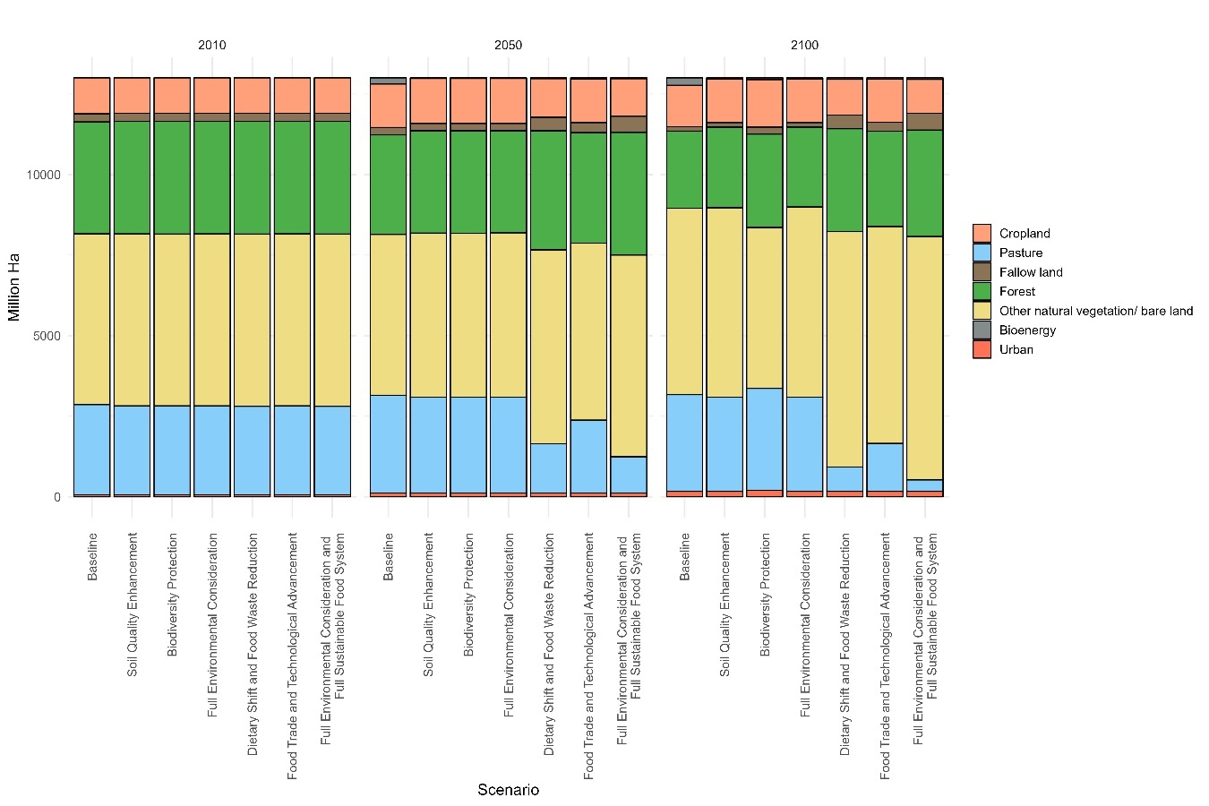

Figure S5. Potential land available for afforestation (A) and afforested land (B) in 2010, 2050, and 2100 under each scenario.

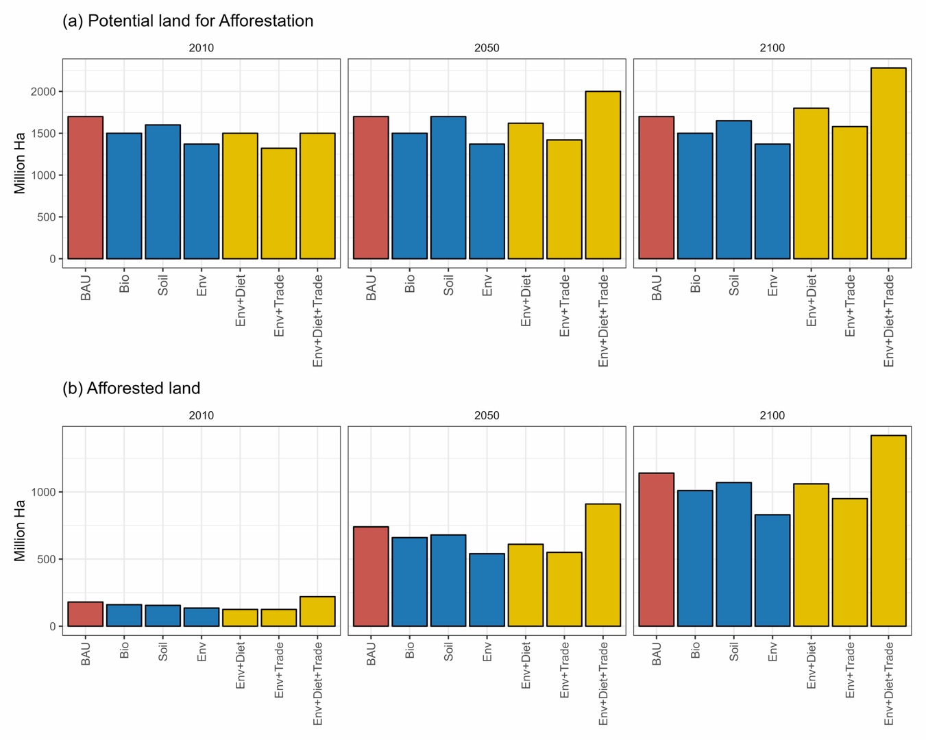

Figure S6. Sensitivity analysis of afforested land area and AFRCSP under the Env+Diet+Trade scenario, considering ±10% variations in the afforestation rate (based on Doelman et al., 2020).

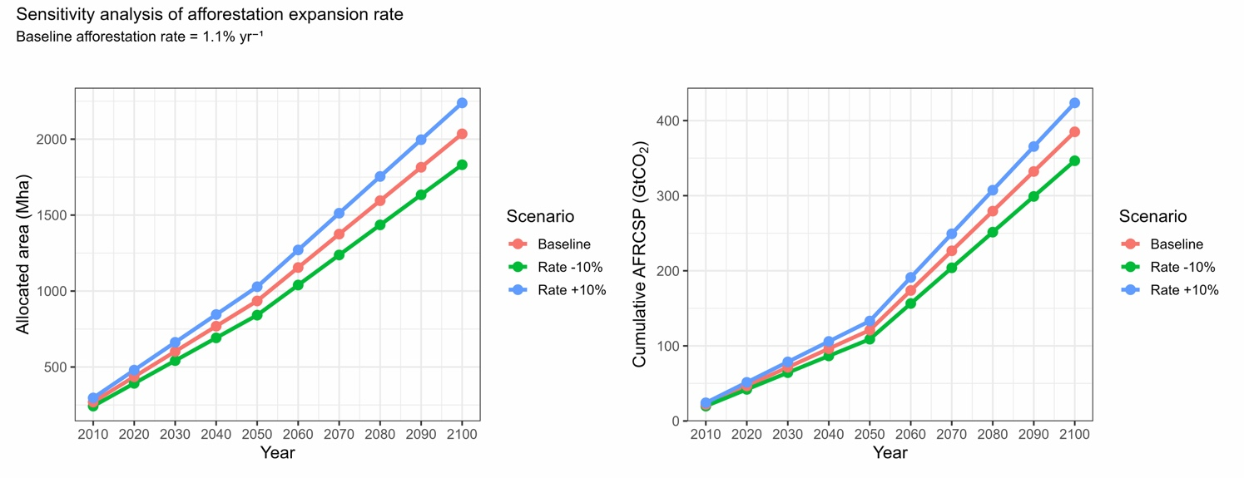

Figure S7. Comparison of Afforestation Carbon Sequestration Potential and Land Requirements Among Global Studies

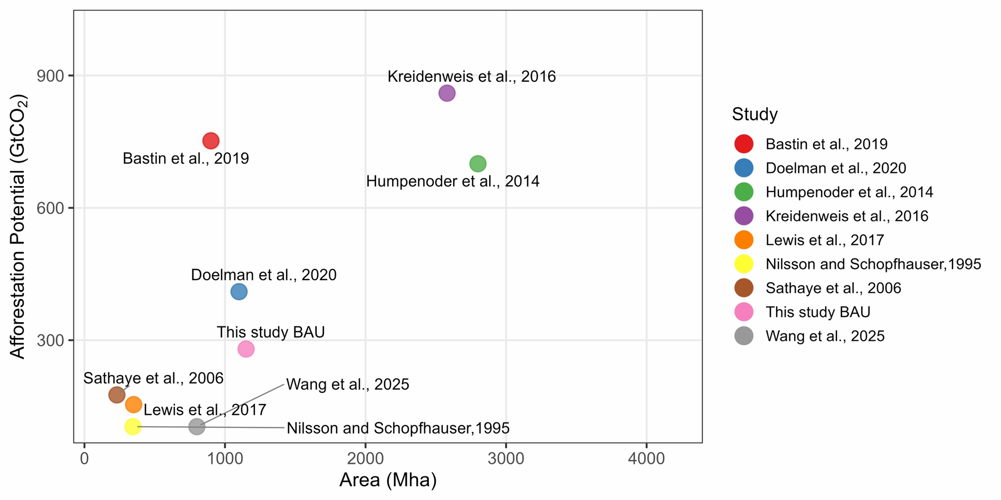This figure show comparison of cumulative afforestation carbon sequestration potential (AFRCSP) across this study and previous studies (Bastin et al. (2019), Humpenöder et al. (2014), Lewis et al. (2019), Nilsson and Schopfhauser (1995), Sathaye et al. (2006), and Wang et al. (2025)). Differences among estimates reflect variations in assumptions regarding land availability, implementation rates, environmental constraints, and carbon accounting approaches.

S.5. Supplementary Information related to scope and limitations

S5.1 Biodiversity Considerations
The biodiversity protection scenario excluded environmentally sensitive areas from afforestation allocation to reduce the risk of biodiversity loss associated with land-use change. While this approach improves environmental safeguards, it may also underestimate afforestation opportunities. Recent studies suggest that afforestation and biodiversity conservation can be compatible when restoration is implemented using native tree species and appropriate forest types (Hasegawa et al., 2024). In addition, restoration efforts may be more suitable in historically forested areas than in naturally unforested ecosystems (Hirata et al., 2024). Future studies should integrate biodiversity models and historical land-cover information to identify locations where afforestation can simultaneously support climate mitigation, ecosystem restoration, and biodiversity conservation.

S5.2 Management Options for Degraded Lands
The Soil scenario prioritized degraded lands that satisfied the minimum forest growth threshold. However, the analysis did not explicitly represent restoration treatments that may improve afforestation performance on degraded lands. Potential interventions include the use of native or nitrogen-fixing tree species, organic amendments, and biochar applications, all of which may improve soil quality and forest productivity. Because the effectiveness and feasibility of these measures vary across locations, future studies should evaluate degraded-land restoration using spatially explicit assessments of site suitability and management requirements.

S5.3 Afforestation Rate
Although sustainable food-system scenarios substantially increased land availability for afforestation, realized afforestation remained constrained by the assumed afforestation rate. Under the Env+Diet+Trade scenario, approximately 2,250 Mha of land was available for afforestation, but only 1,900 Mha was afforested by 2100 after applying afforestation-rate constraints (Figures S6). This result highlights the importance of implementation capacity in determining realized AFRCSP. Sensitivity analysis of alternative afforestation-rate assumptions is presented in Figure S6. Future research should explore region-specific afforestation capacities and policy mechanisms that could support sustainable forest establishment.

Reference
Ardra, S., & Barua, M. K. (2022). Halving food waste generation by 2030: The challenges and strategies of monitoring UN sustainable development goal target 12.3. Journal of Cleaner Production, 380, 135042.
Bastin, J. F., Finegold, Y., Garcia, C., Mollicone, D., Rezende, M., Routh, D., ... & Crowther, T. W. (2019). The global tree restoration potential. Science, 365(6448), 76-79. doi:10.1126/science.aax0848
BirdLife International. (2017). World database of key biodiversity areas. Developed by the KBA partnership. BirdLife International, International Union for the Conservation of Nature, Amphibian Survival Alliance, Conservation International, Critical Ecosystem Partnership Fund, Global Environment Facility, Global Wildlife Conservation, NatureServe, Rainforest Trust, Royal Society for the Protection of Birds, Wildlife Conservation Society and World Wildlife Fund. Retrieved January 8, 2018, from www.keybiodiversityareas.org
Crowe, S., Johnson, K., Martinez, A., & Patel, R. (2023). Forest coverage and biodiversity in Key Biodiversity Areas (KBAs). Global Ecology and Conservation, 34, e02234. doi:10.1016/j.gecco.2023.02234
Doelman, J. C., Stehfest, E., van Vuuren, D. P., Hof, A. F., Braakhekke, M. C., Gernaat, D. E. H. J., van den Berg, M., van Zeist, W.-J., Daioglou, V., van Meijl, H., Lucas, P. L., & Tabeau, A. (2020). Afforestation for climate change mitigation: Potentials, risks and trade-offs. Global Change Biology, 26(3), 1576–1591. https://doi.org/10.1111/gcb.14887
Fujimori, S., Masui, T., & Yuzuru, M. (2012). AIM-HUB [basic] manual (Discussion paper series Center for Social and Environmental Systems Research). Tsukuba, Japan: NIES.
Hanasaki, N., Kanae, S., Oki, T., Masuda, K., Motoya, K., Shirakawa, N., Shen, Y., & Tanaka, K. (2013). An integrated model for the assessment of global water resources – Part 2: Applications and assessments. Hydrology and Earth System Sciences, 17(3), 1069-1080. doi:10.5194/hess-17-1069-2013
Hasegawa, T., Fujimori, S., Shin, Y., Takahashi, K., Masui, T., & Tanaka, A. (2014). Climate change impact and adaptation assessment on food consumption utilizing a new scenario framework. Environmental Science & Technology, 48, 438–445. https://doi. org/10.1021/es4034149
Hasegawa, T., Fujimori, S., Shin, Y., Tanaka, A., Takahashi, K., & Masui, T. (2015a). Consequence of climate mitigation on the risk of hunger. Environmental Science & Technology, 49, 7245–7253. https://doi.org/10.1021/es5051748
Hasegawa, T., Fujimori, S., Takahashi, K., & Masui, T. (2015b). Scenarios for the risk of hunger in the twenty‐first century using Shared Socioeconomic Pathways. Environmental Research Letters, 10, 014010. https://doi.org/10.1088/1748-9326/10/1/014010
Hasegawa, T., Fujimori, S., Takahashi, K., Yokohata, T., & Masui, T. (2016). Economic implications of climate change impacts on human health through undernourishment. Climatic Change, 136, 189–202. https://doi.org/10.1007/s10584-016-1606-4
Hasegawa, T., Fujimori, S., Ito, A., Takahashi, K., & Masui, T. (2017). Global land‐use allocation model linked to an integrated assessment model. Science of the Total Environment, 580, 787–796. https://doi.org/10.1016/j.scitotenv.2016.12.025
Hasegawa, T., Fujimori, S., Ito, A. et al. (2024). Careful selection of forest types in afforestation can increase CS by 25% without compromising sustainability. Commun Earth Environ 5, 171. https://doi.org/10.1038/s43247-024-01336-4
Hirata, A., Ohashi, H., Hasegawa, T. et al. (2024). The choice of land-based climate change mitigation measures influences future global biodiversity loss. Commun Earth Environ 5, 259 (2024). https://doi.org/10.1038/s43247-024-01433-4

Hoogwijk, M., Faaij, A., de Vries, B., & Turkenburg, W. (2009). Exploration of regional and global cost–supply curves of biomass energy from short‐rotation crops at abandoned cropland and rest land under four IPCC SRES land‐use scenarios. Biomass Bioenergy, 33, 26–43. https://doi.org/10.1016/j.biombioe.2008.04.005
Humpenöder, F., Popp, A., Dietrich, J. P., Klein, D., Lotze-Campen, H., Bonsch, M., ... & Bodirsky, B. L. (2014). Investigating afforestation and bioenergy CCS as climate change mitigation strategies. Environmental Research Letters, 9(6), 064029. doi:10.1088/1748-9326/9/6/064029
IUCN and UNEP‐WCMC (2018). The World Database on Protected Areas (WDPA) [Online], [Jan/2018 of the version downloaded]. Cambridge, UK: UNEP‐WCMC. Retrieved from www.protectedplanet.net
Intergovernmental Panel on Climate Change (IPCC). (2016). Summary for Policymakers. In: Global Warming of 1.5°C. An IPCC Special Report on the impacts of global warming of 1.5°C above pre-industrial levels and related global greenhouse gas emission pathways, in the context of strengthening the global response to the threat of climate change, sustainable development, and efforts to eradicate poverty [Masson-Delmotte, V., et al. (eds.)]. World Meteorological Organization, Geneva, Switzerland.
Kreidenweis, U., Humpenöder, F., Stevanović, M., Bodirsky, B. L., Kriegler, E., Lotze-Campen, H., & Popp, A. (2016). Afforestation to mitigate climate change: impacts on food prices under consideration of albedo effects. Environmental Research Letters, 11(8), 085001. doi:10.1088/1748-9326/11/8/085001
Lefebvre, D., Williams, A. G., Kirk, G. J. D., Paul, Burgess, J., Meersmans, J., Silman, M. R., Román-Dañobeytia, F., Farfan, J., & Smith, P . (2021). Assessing the carbon capture potential of a reforestation project. Scientific Reports, 11(1), 19907. https://doi.org/10.1038/s41598-021-99395-6
Lewis, S. L., Wheeler, C. E., Mitchard, E. T., & Koch, A. (2019). Restoring natural forests is the best way to remove atmospheric carbon. Nature, 568(7750), 25-28. doi:10.1038/d41586-019-01026-8
Nachtergaele, F., & Petri, M. (2011). Mapping land use systems at global and regional scales for land degradation assessment analysis (Version 1.1). In F. Nachtergaele & R. Biancalani (Eds.), Land Degradation Assessment in Drylands (LADA). Food and Agriculture Organization of the United Nations (FAO).

Nilsson, S., & Schopfhauser, W. (1995). The carbon-sequestration potential of a global afforestation program. Climatic Change, 30(3), 267–293. https://doi.org/10.1007/BF01091928
Ohashi, H., Yonekura, Y., Hirata, A., Takano, K., Nishijima, S., & Matsui, T.. (2017). The effect of climate change on the extinction risk of living organisms on the global scale: evaluation of the effect and side effects of mitigation measures. In Organized session T05: Mitigation / Adaptation Measures of Climate Change: Relationship from Ecosystem Impact Prediction to Human Activities, The 64th Meeting of Ecological Society of Japan (in Japanese).
Phillips, S. J., Anderson, R. P., & Schapire, R. E. (2006). Maximum entropy modeling of species geographic distributions. Ecological Modelling, 190(3–4), 231–259. https://doi.org/10.1016/j.ecolmodel.2005.03.026
Sathaye, J., Andrasko, K., & Chan, P. (2006). Emission mitigation potentials and costs for forest management in tropical Asia. Mitigation and Adaptation Strategies for Global Change, 11(4), 891-905. doi:10.1007/s11027-005-7799-7
Sohngen, B., Golub, A. A., & Hertel, T. W. (2009). The role of forestry in CS in general equilibrium models. In T. W. Hertel, S. K. Rose, & R. S. J. Tol (Eds.), Economic analysis of land use in global climate change policy (pp. 279-302). London, UK: Routledge.
van Vuuren, D. P., van Vliet, J., & Stehfest, E. (2009). Future bio‐energy potential under various natural constraints. Energy Policy, 37, 4220–4230. https://doi.org/10.1016/j.enpol.2009.05.029
von Lampe, M., Willenbockel, D., Ahammad, H., Blanc, E., Cai, Y., Calvin, K., Fujimori, S., Hasegawa, T., Havlík, P., Heyhoe, E., Kyle, P., Nelson, G. C., Ruane, A., Schmitz, C., van Meijl, H., Valin, H., & Witzke, P. (2014). Why do global long-term scenarios for agriculture differ? An overview of the AgMIP Global Economic Model Intercomparison. Agricultural Economics, 45(1), 3–20. https://doi.org/10.1111/agec.12086

Wang, Y., Poulter, B., Broquet, G., Hartung, K., Goll, D., & Ciais, P. (2025). Country-level assessment of afforestation carbon sequestration potential. Global Change Biology.
Winsten, J., Walker, S., Brown, S., & Grimland, S. (2011). Estimating carbon supply curves from afforestation of agricultural land in the Northeastern U.S. Mitigation and Adaptation Strategies for Global Change, 16, 925–942.
Willett, W., Rockström, J., Loken, B., Springmann, M., Lang, T., Vermeulen, S., Garnett, T., Tilman, D., DeClerck, F., & Wood, A. (2019). Food in the Anthropocene: The EAT–Lancet Commission on healthy diets from sustainable food systems. The Lancet, 393(10170), 447–492.
Wu, W., Hasegawa, T., Ohashi, H., Hanasaki, N., Liu, J., Matsui, T., … Takahashi, K. (2019). Global advanced bioenergy potential under environmental protection policies and societal transformation measures. GCB Bioenergy, 11(7), 718–731. https://doi.org/10.1111/gcbb.12614

